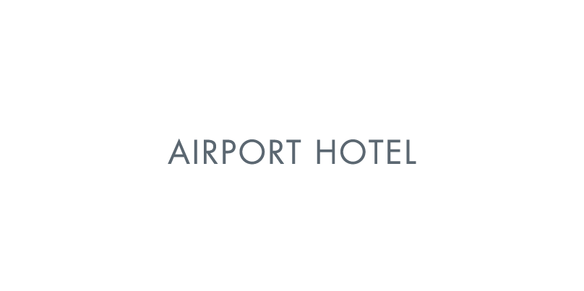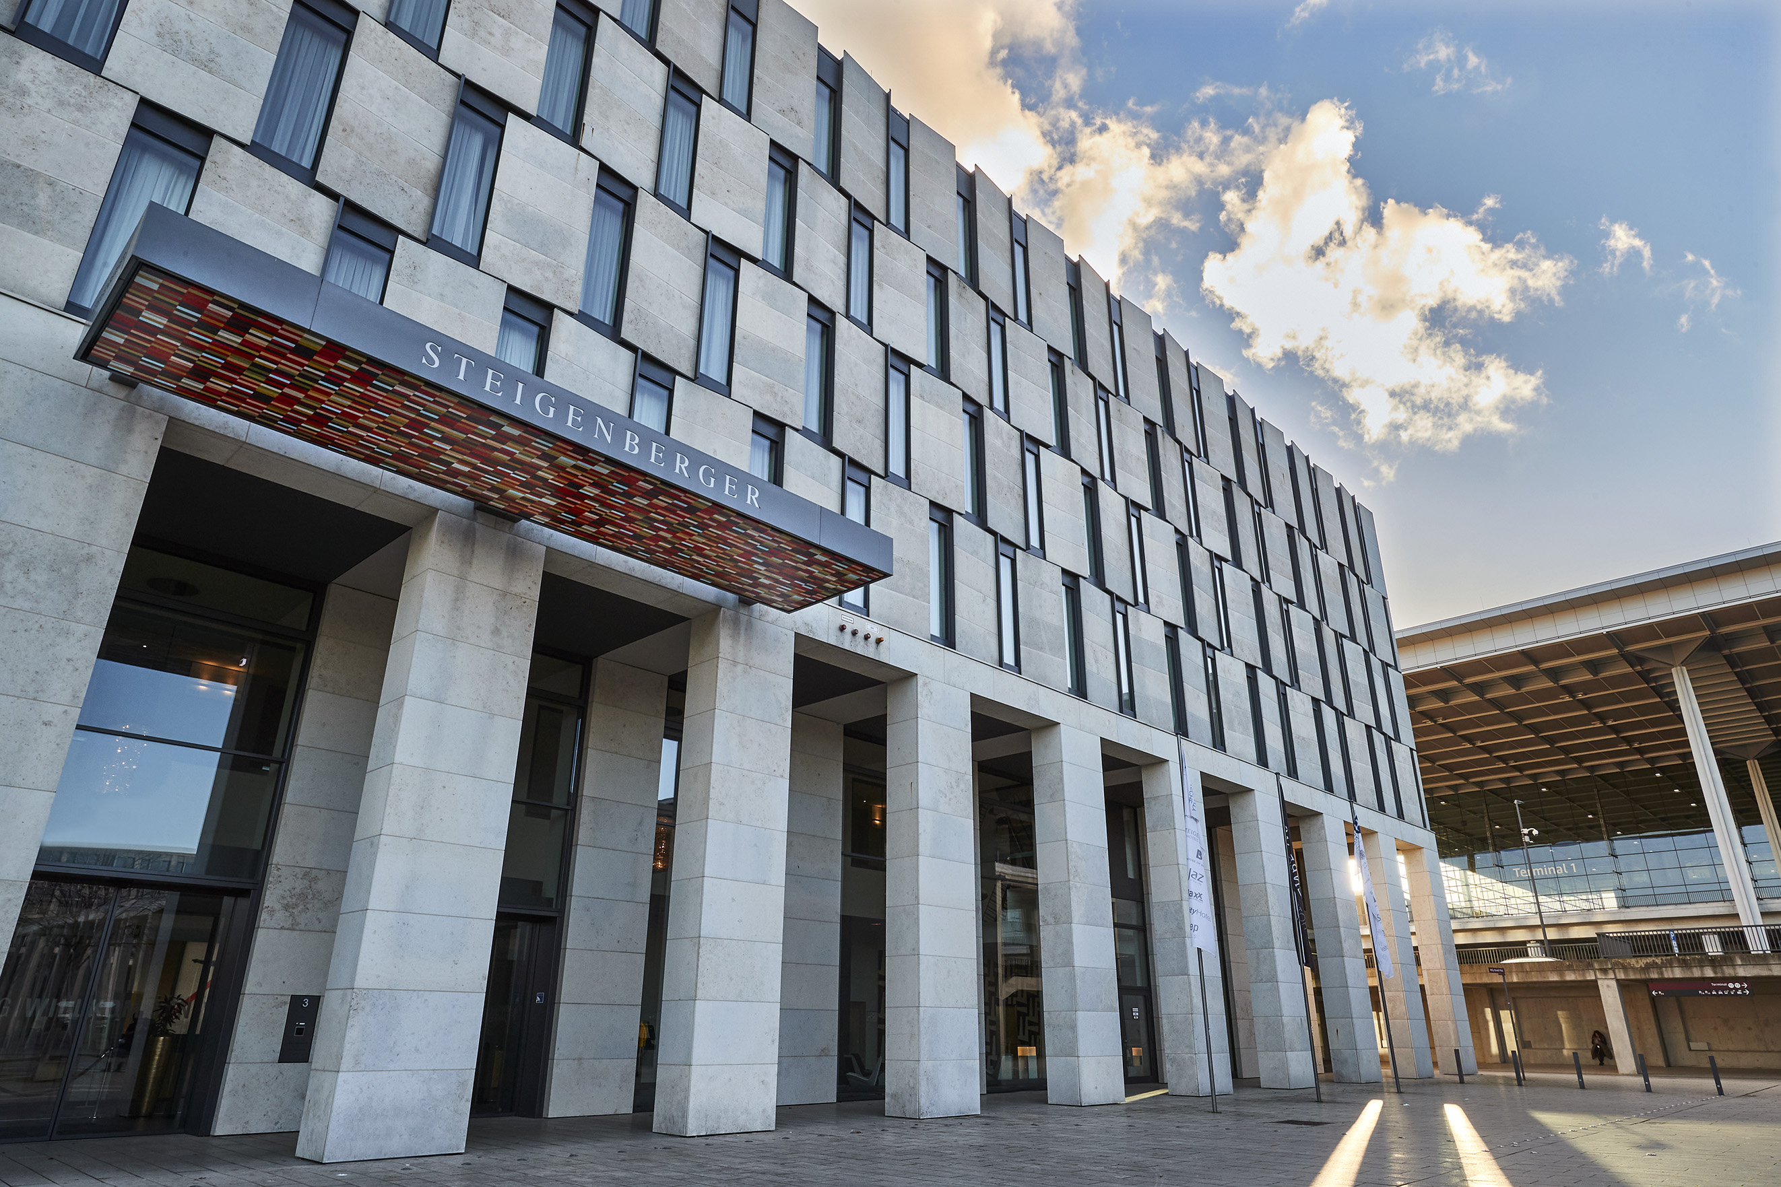



**Steigenberger Airport Hotel Berlin**

Willy-Brandt-Platz 3 | 12529 Schönefeld, Germany

**T** +49 30 246497-0 | **E** meetings.berlin-airport@steigenberger.com

airporthotel-berlin.steigenberger.com

MEET, SLEEP & FLY.

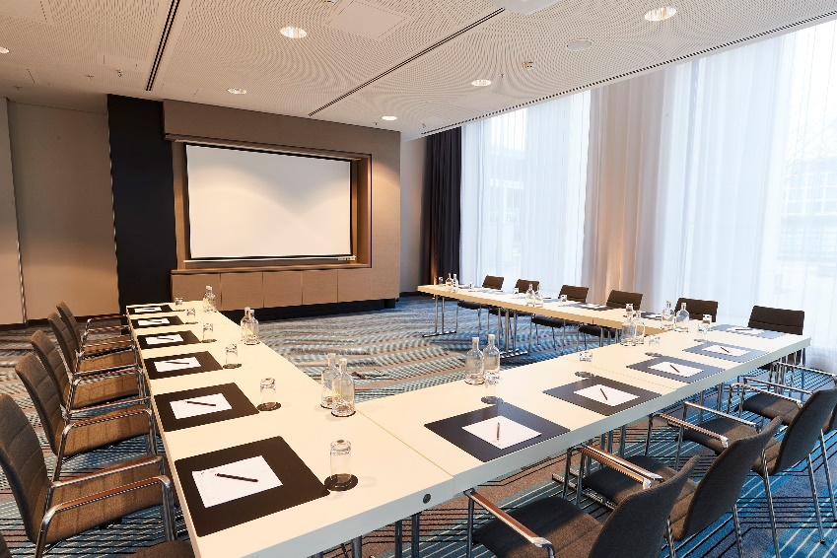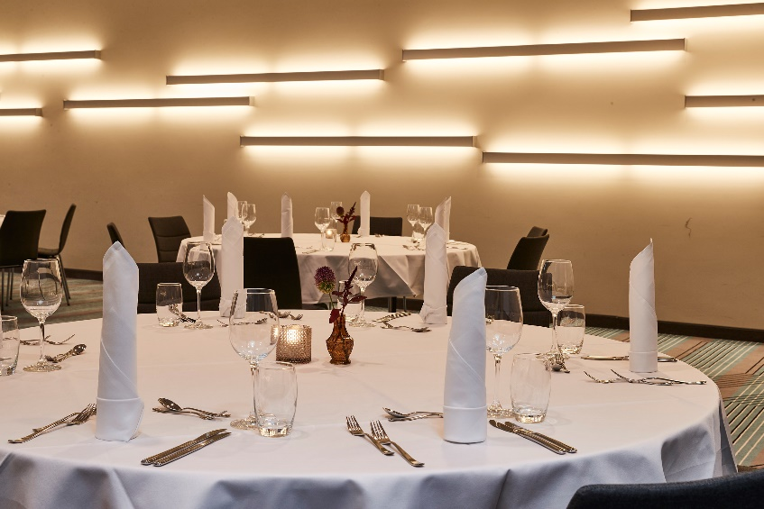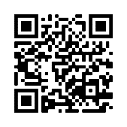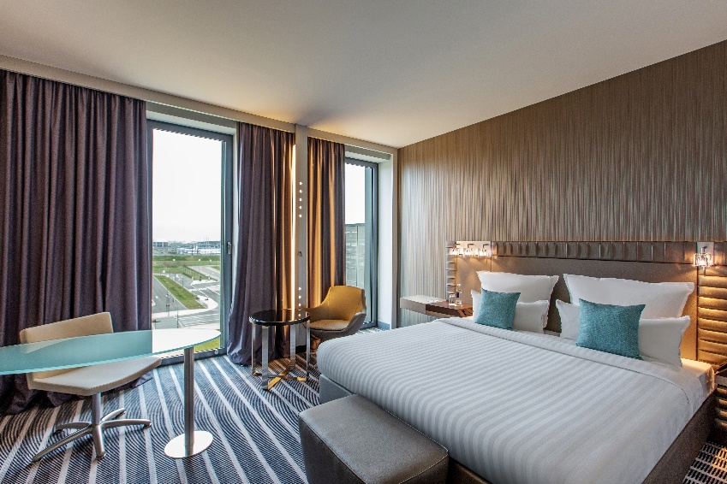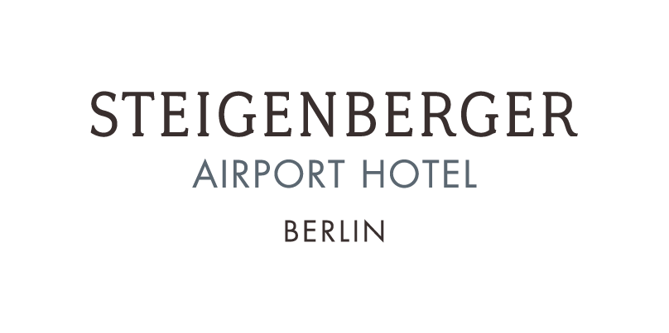

**Restaurants and Bars**

* Restaurant with approx. 250 seats
* Bistro with approx. 50 seats
* Bar with approx. 40 seats
* Terrace with approx. 25 seats

**Meetings and Events**

* 12 conference rooms for up to 300 people
* Total of approx. 1200 m2 event area
* All rooms on ground floor, air-conditioned,

soundproofed and partly with daylight

* Sustainable Green-Meeting concept
* Possibility for hybrid meetings
* Ideal requirements for car presentations

**Rooms and Services**

* 322 air-conditionied rooms: 267 Superior,

21 Deluxe, 22 Junior Suites, 12 Suites

* Wheelchair-accessible rooms
* Free highspeed Wifi in the whole hotel
* 24h roomservice

**Distances**

* Airport 50 m
* Public parking garage 50 m
* Train station (ICE/S-Bahn) 50 m
* Highway (A 113) 3,0 km
* Berlin center 25 min (direct connection with

public transport)

Scan the QR code and receive

more Information or visit us at

airporthotel-berlin.steigenberger.com

**Fitness und Wellness**

* Fitness- and gym area
* Sauna and steambath
* Massage room
* Relaxation room

___________________________________________________________________________________________________________________________



|  |  |  |  |  |  |  |  |  |  |
| --- | --- | --- | --- | --- | --- | --- | --- | --- | --- |
|  |  |  | **Circle of Chairs** | **Classroom** | **Theatre** | **U-Shape** | **Banquet** | **Boardroom** | **Daylight** |
|  | **m²** | **Measures (m)** |  |  |  |  |  |  |  |
| Conference 1 | 242 | 11 x 22 x 4 | 65 | 144 | 180 | 54 | 150 | 54 | - |
| Conference 2 | 242 | 11 x 22 x 4 | 65 | 144 | 180 | 54 | 150 | 54 | - |
| Conference 1+2 | 484 | 22 x 22 x 4 | 130 | 288 | 300 | 78 | 300 | 108 | - |
| Conference 3 | 46 | 4,85 x 9,4 x 3,7 | 20 | 24 | 42 | 21 | 30 | 21 | Häkchen |
| Conference 4 | 46 | 4,85 x 9,4 x 3,7 | 20 | 24 | 42 | 21 | 30 | 21 | Häkchen |
| Conference 3+4 | 92 | 9,7 x 9,4 x 3,7 | 50 | 48 | 84 | 27 | 60 | 27 | Häkchen |
| Conference 5 | 30 | 4,3 x 6,8 x 3,7 | 12 | 18 | 24 | 15 | 20 | 15 | - |
| Conference 6 | 31 | 4,5 x 6,8 x 3,7 | 12 | 18 | 24 | 15 | 20 | 15 | - |
| Conference 7 | 42 | 6,1 x 6,8 x 3,7 | 16 | 18 | 30 | 18 | 30 | 18 | - |
| Conference 5+6 | 61 | 6,8 x 8,8 x 3,7 | 30 | 36 | 48 | 21 | 50 | 30 | - |
| Conference 6+7 | 72 | 6,8 x 10,6 x 3,7 | 35 | 36 | 55 | 24 | 50 | 30 | - |
| Conference 5+6+7 | 102 | 6,8 x 14,9 x 3,7 | 50 | 54 | 80 | 42 | 70 | 42 | - |
| Conference 8 | 37 | 5,4 x 6,8 x 3,7 | 16 | 18 | 30 | 12 | 20 | 12 | Häkchen |
| Conference 9 | 31 | 4,5 x 6,8 x 3,7 | 12 | 15 | 18 | 15 | 20 | 15 | Häkchen |
| Conference 10 | 30 | 4,3 x 6,8 x 3,7 | 12 | 15 | 18 | 15 | 20 | 15 | Häkchen |
| Conference 8+9 | 67 | 6,8 x 9,9 x 3,7 | 32 | 32 | 48 | 30 | 50 | 30 | Häkchen |
| Conference 9+10 | 60 | 6,8 x 8,8 x 3,7 | 24 | 30 | 36 | 24 | 40 | 24 | Häkchen |
| Conference 8+9+10 | 100 | 6,8 x 14,2 x 3,7 | 50 | 45 | 70 | 42 | 60 | 42 | Häkchen |
| Conference 11 | 68 | 8,5 x 8 x 3,7 | 25 | 24 | 40 | 16 | 40 | 24 | Häkchen |
| Conference 12 | 30 | 6,8 x 4,3 x 3,7 | 12 | 15 | 18 | 15 | 20 | 15 | Häkchen |
| Foyer 1 | 230 |  |  |  |  |  |  |  | Häkchen |
| Foyer 2 | 130 | - | - | - | - | - | - | - | Häkchen |
| Restaurant | 560 | - | - | - | - | - | - | - | Häkchen |

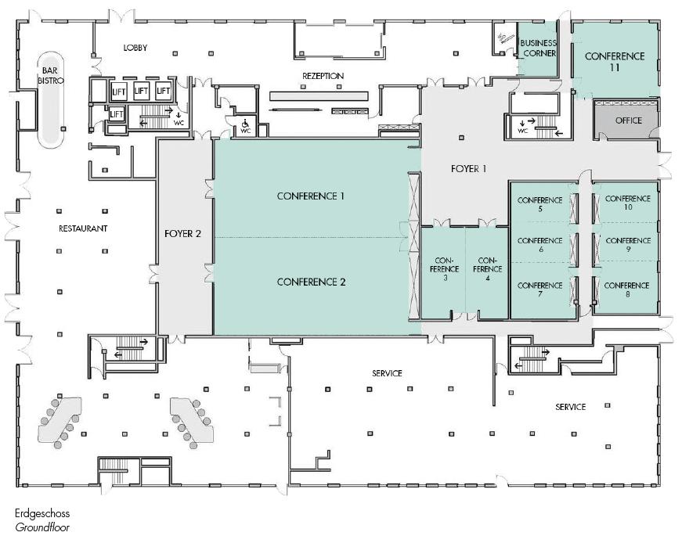

Conference

12

